

Practices for Secure Software Report

Table of Contents
Document Revision History 3
Client 3
Instructions 3
Developer 4
1. Algorithm Cipher 4
2. Certificate Generation 4
3. Deploy Cipher 4
4. Secure Communications 4
5. Secondary Testing 4
6. Functional Testing 4
7. Summary 4
8. Industry Standard Best Practices 4

Document Revision History

Version | Date | Author | Comments
1.0 | 08/19/2026 | Jacob Carlson

Client



Instructions

Submit this completed practices for secure software report. Replace the bracketed text with the relevant information. You must document your process for writing secure communications and refactoring code that complies with software security testing protocols.

- Respond to the steps outlined below and include your findings.
- Respond using your own words. You may also choose to include images or supporting materials. If you include them, make certain to insert them in all the relevant locations in the document.
- Refer to the Project Two Guidelines and Rubric for more detailed instructions about each section of the template.

Developer
Jacob Carlson

Algorithm Cipher

For Artemis Financial, I would recommend using AES for encryption and SHA-256 for hashing. AES is a strong encryption algorithm that is commonly used today to protect sensitive data. Since Artemis Financial is dealing with financial information, it is important to use an encryption method that is secure and has not become outdated. AES can use 128-, 192-, or 256-bit keys. I would recommend AES-256 because the larger key size provides a higher level of protection against attacks.

For hashing, I would use SHA-256. SHA-256 creates a 256-bit hash from the information that is entered into it. Hashing is different from encryption because it is meant to be a one-way process. Instead of encrypting information and later decrypting it, a hash can be used to check whether information has been changed. For this application, SHA-256 will be used to create a checksum. If the data changes, the checksum will also change, which can help identify whether the information has been modified.

Keys and random numbers also play an important role in keeping encryption secure. Symmetric encryption, such as AES, uses the same key to encrypt and decrypt information. Asymmetric encryption uses two different keys, which are a public key and a private key. The public key can be shared, while the private key needs to remain secure. Secure random numbers are also important because predictable values could make encryption easier to attack. For this project, I generated a 2,048-bit RSA key pair that will be used with the self-signed certificate for HTTPS.

Encryption has changed a lot as technology has improved. Older algorithms such as DES and older hashing methods such as MD5 and SHA-1 are no longer recommended for secure applications because weaknesses have been found over time. More modern algorithms such as AES and SHA-256 provide better security and are commonly used in current applications. Using these newer methods will help Artemis Financial protect sensitive information and make sure that data being sent through the application remains secure.

Certificate Generation
Insert a screenshot below of the CER file.

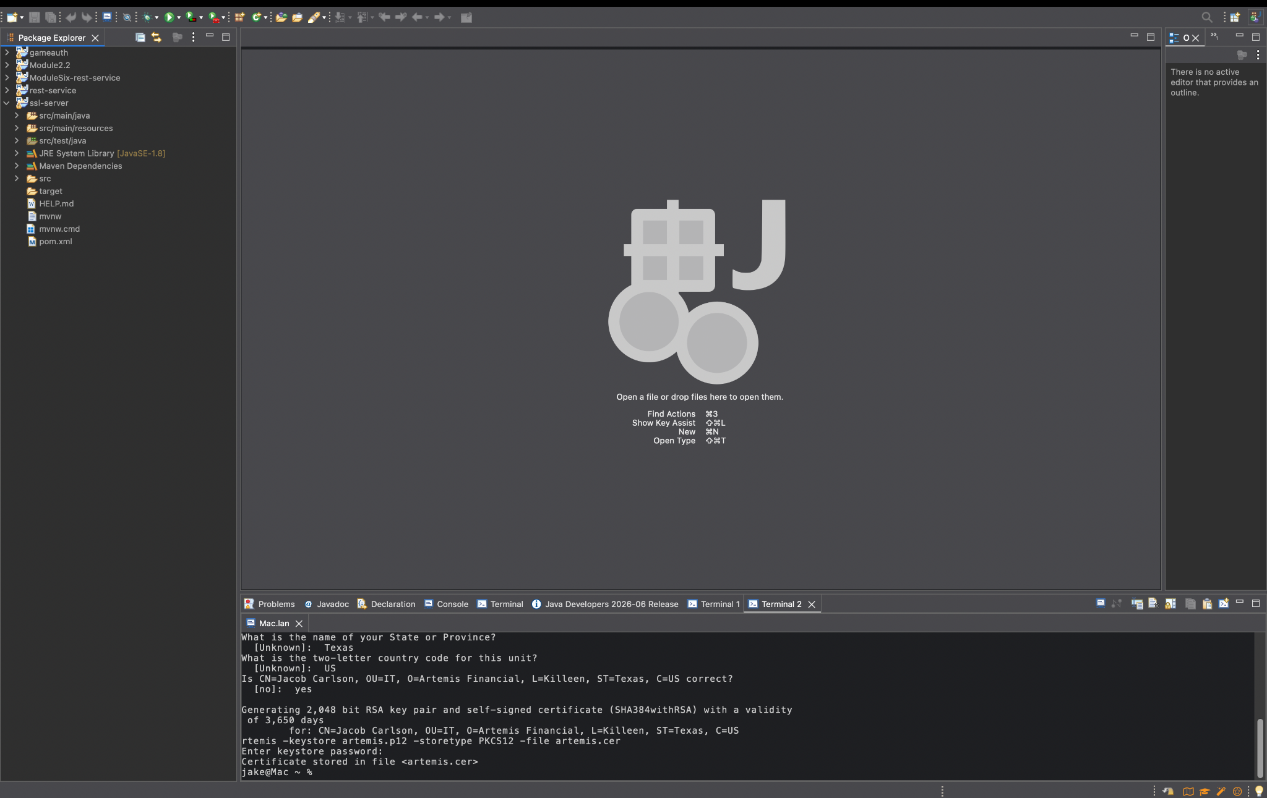

Deploy Cipher
Insert a screenshot below of the checksum verification.



Secure Communications
Insert a screenshot below of the web browser that shows a secure webpage.

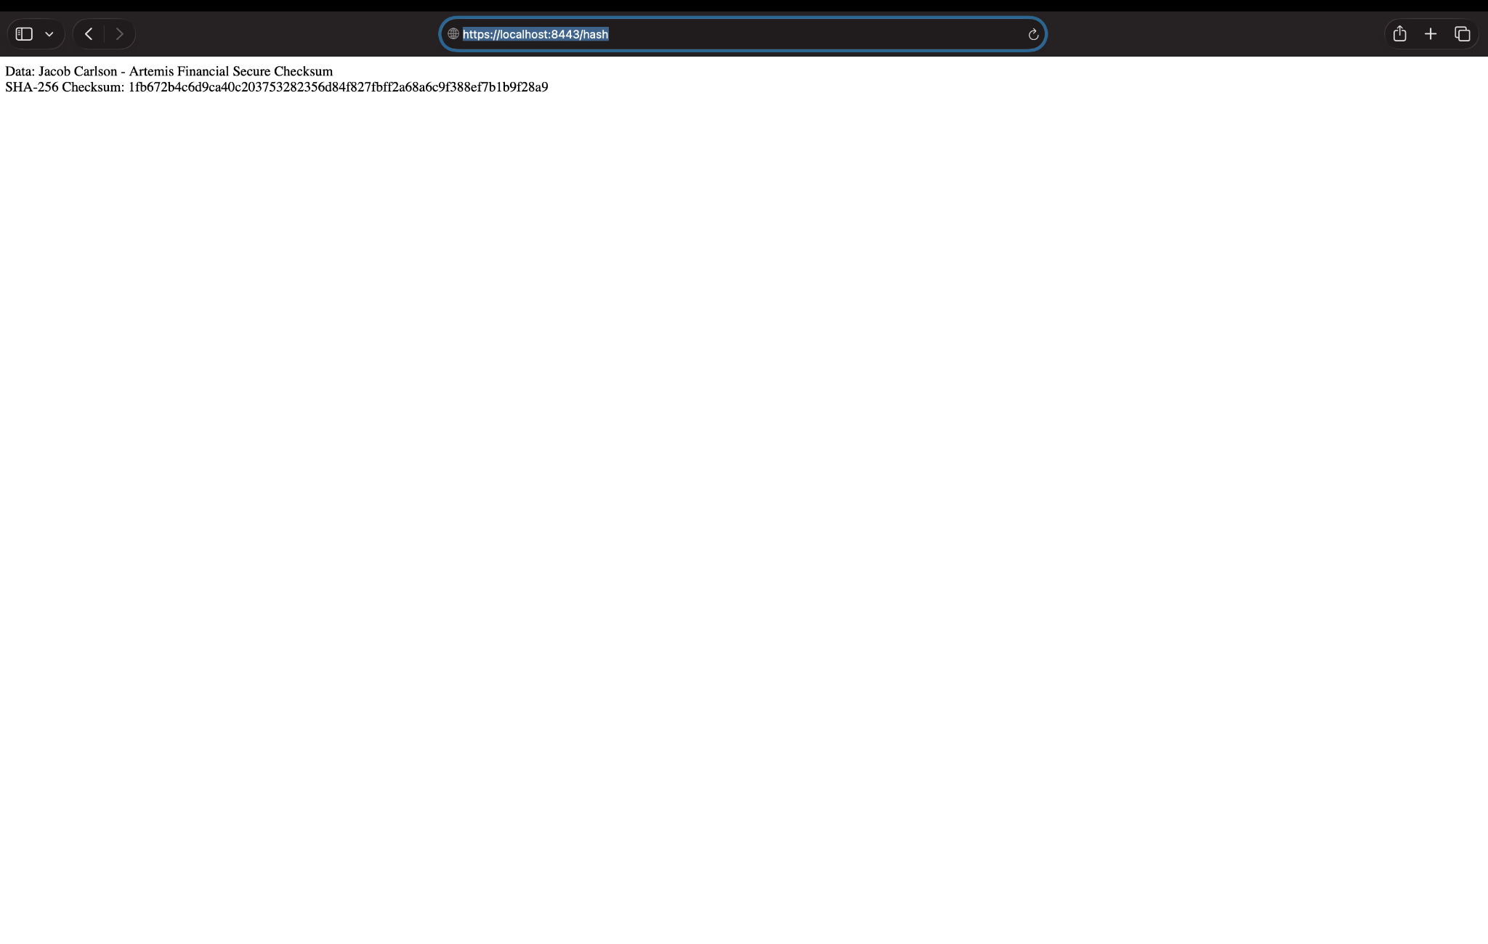

Secondary Testing
Insert screenshots below of the refactored code executed without errors and the dependency-check report.

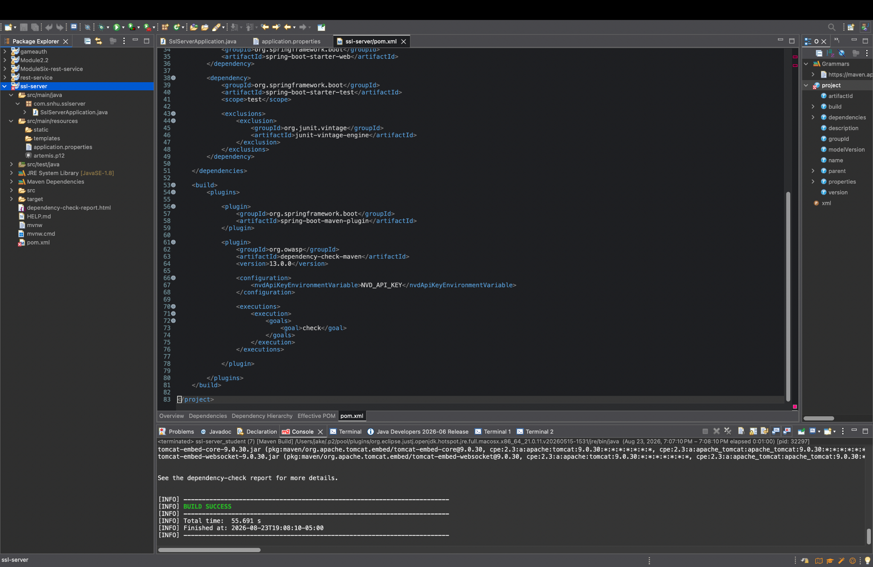
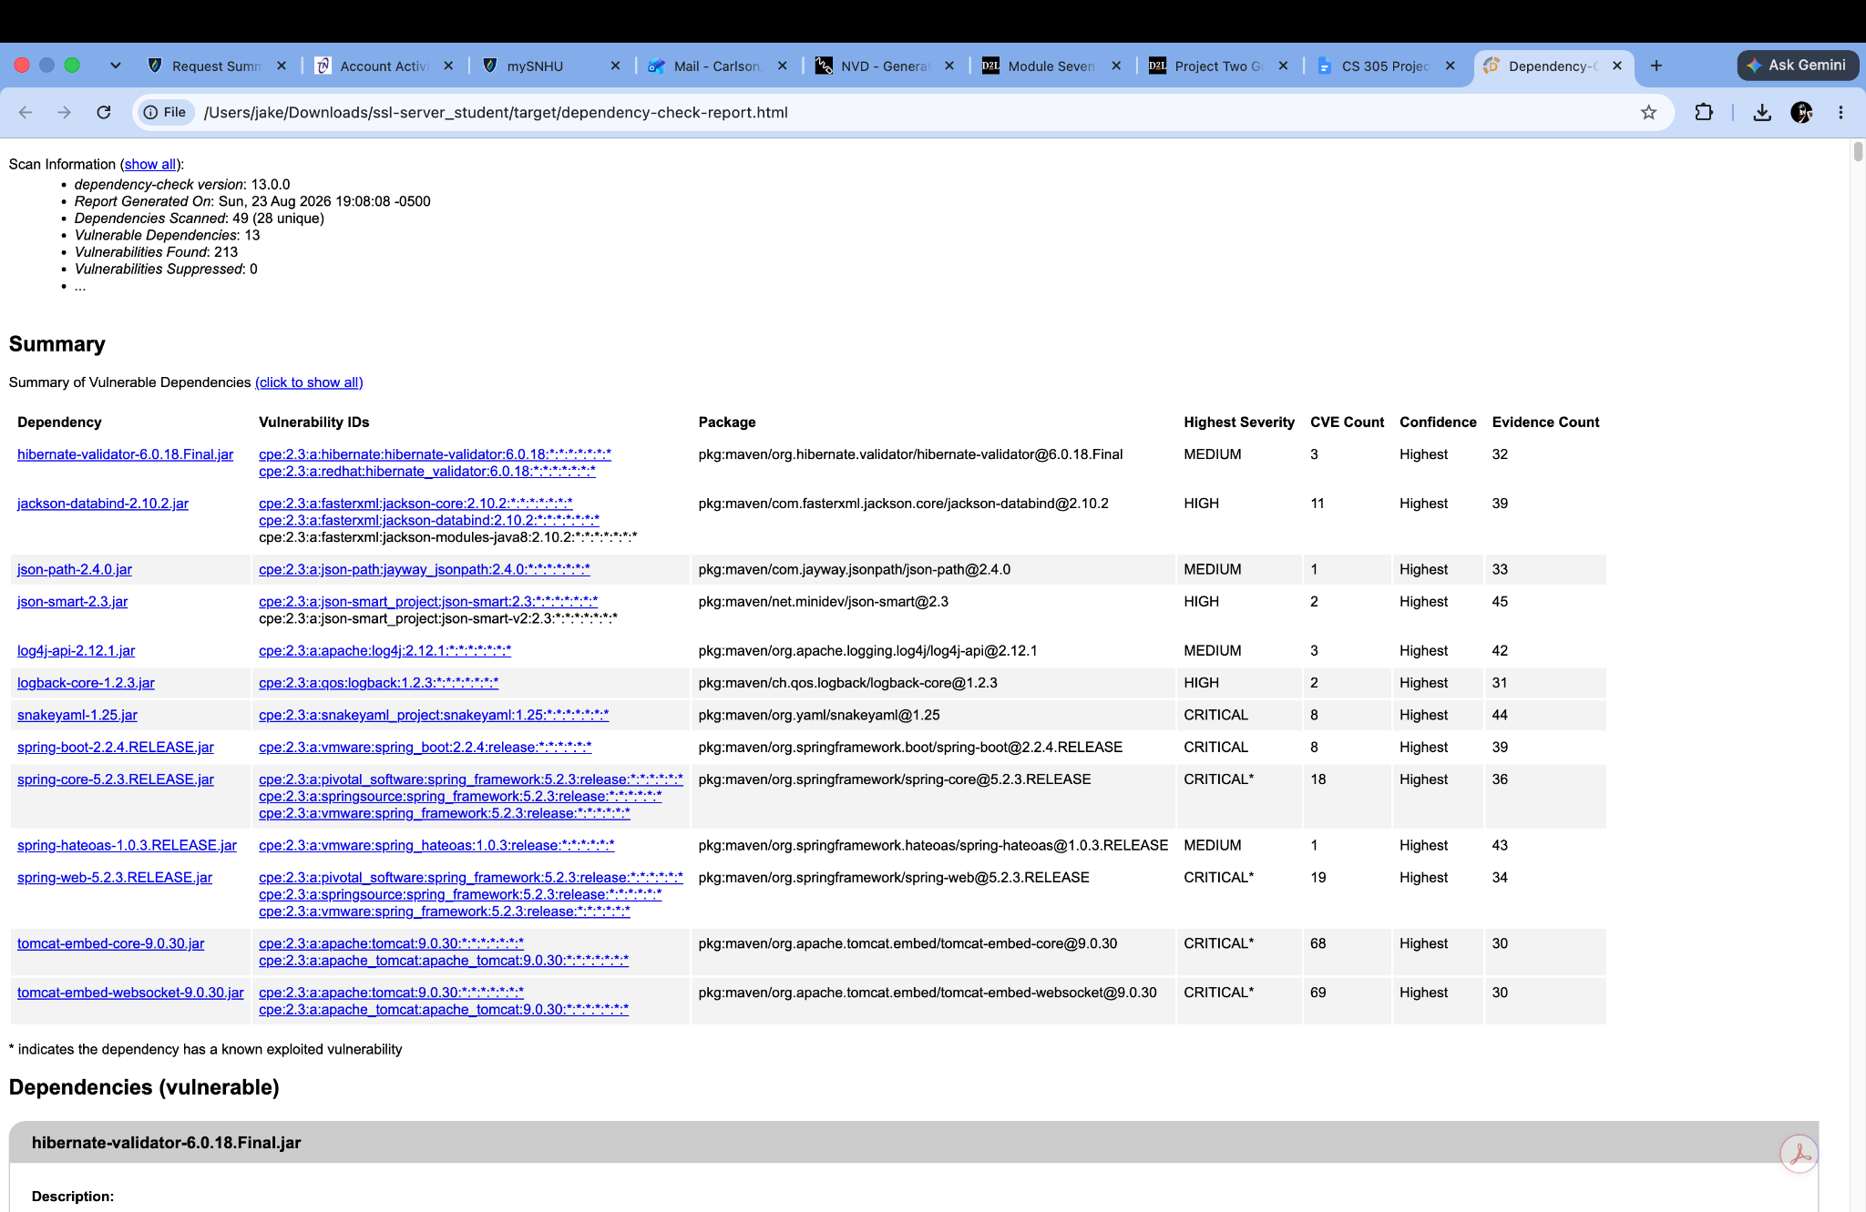

Functional Testing
Insert a screenshot below of the refactored code executed without errors.

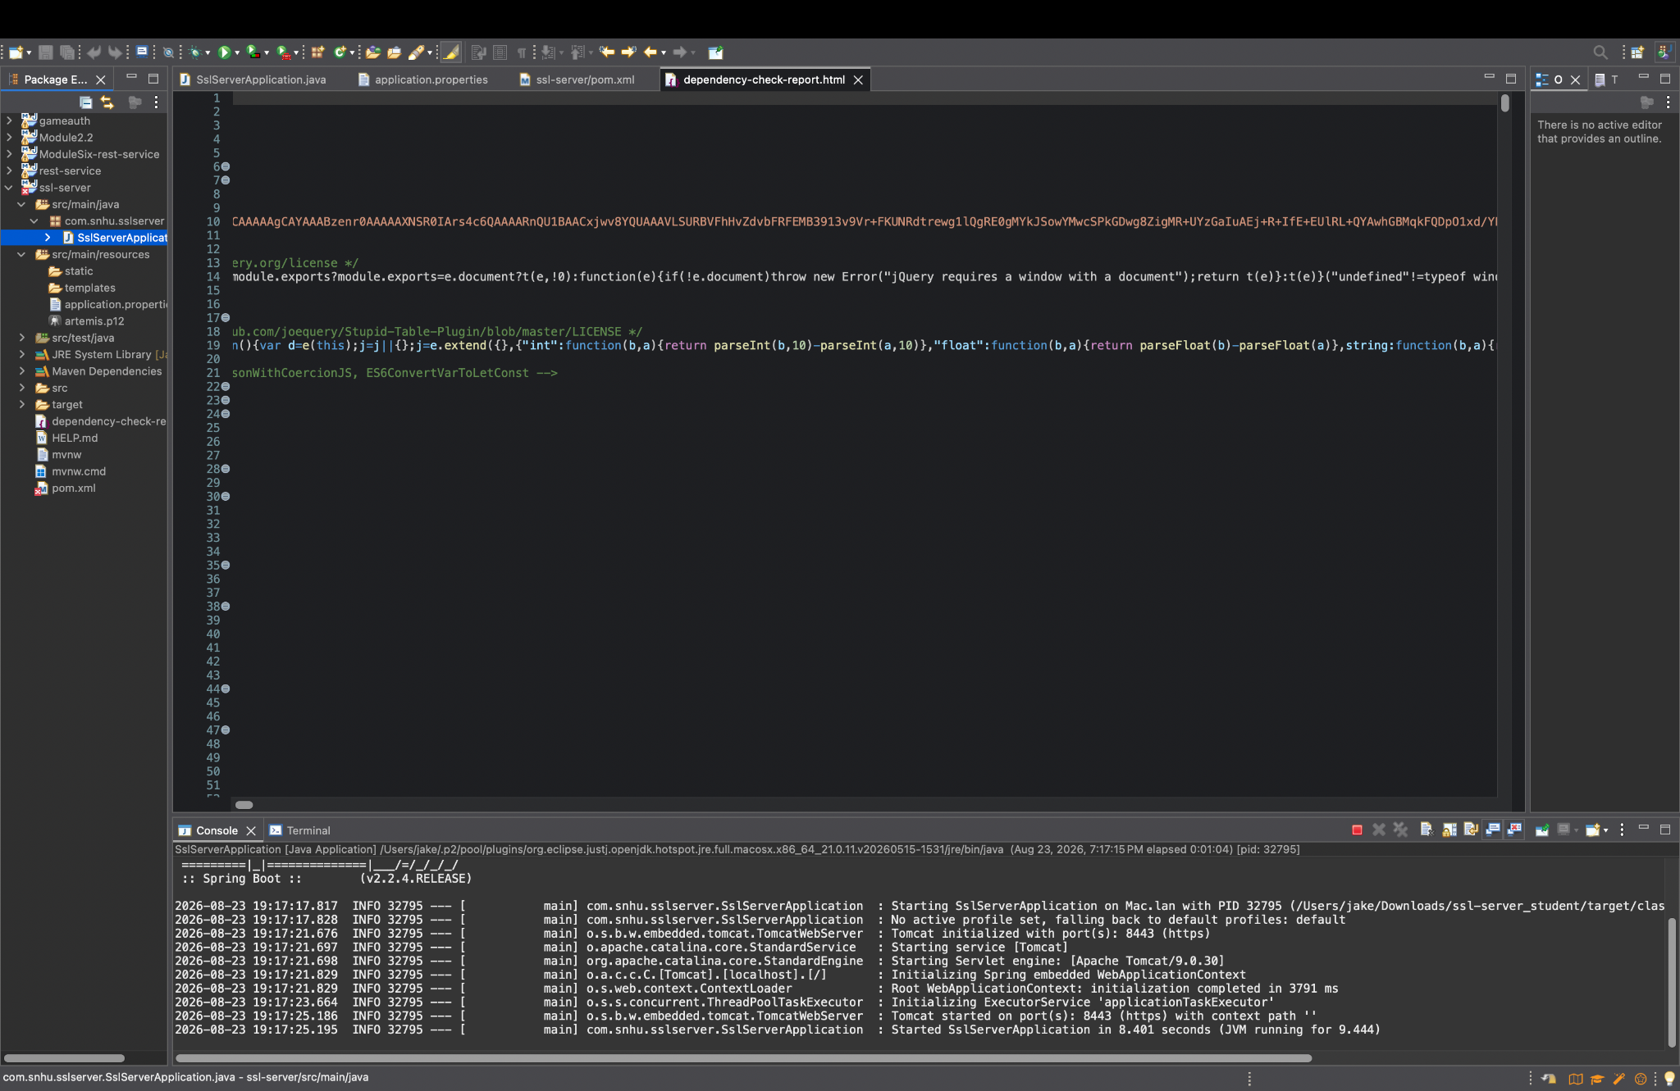
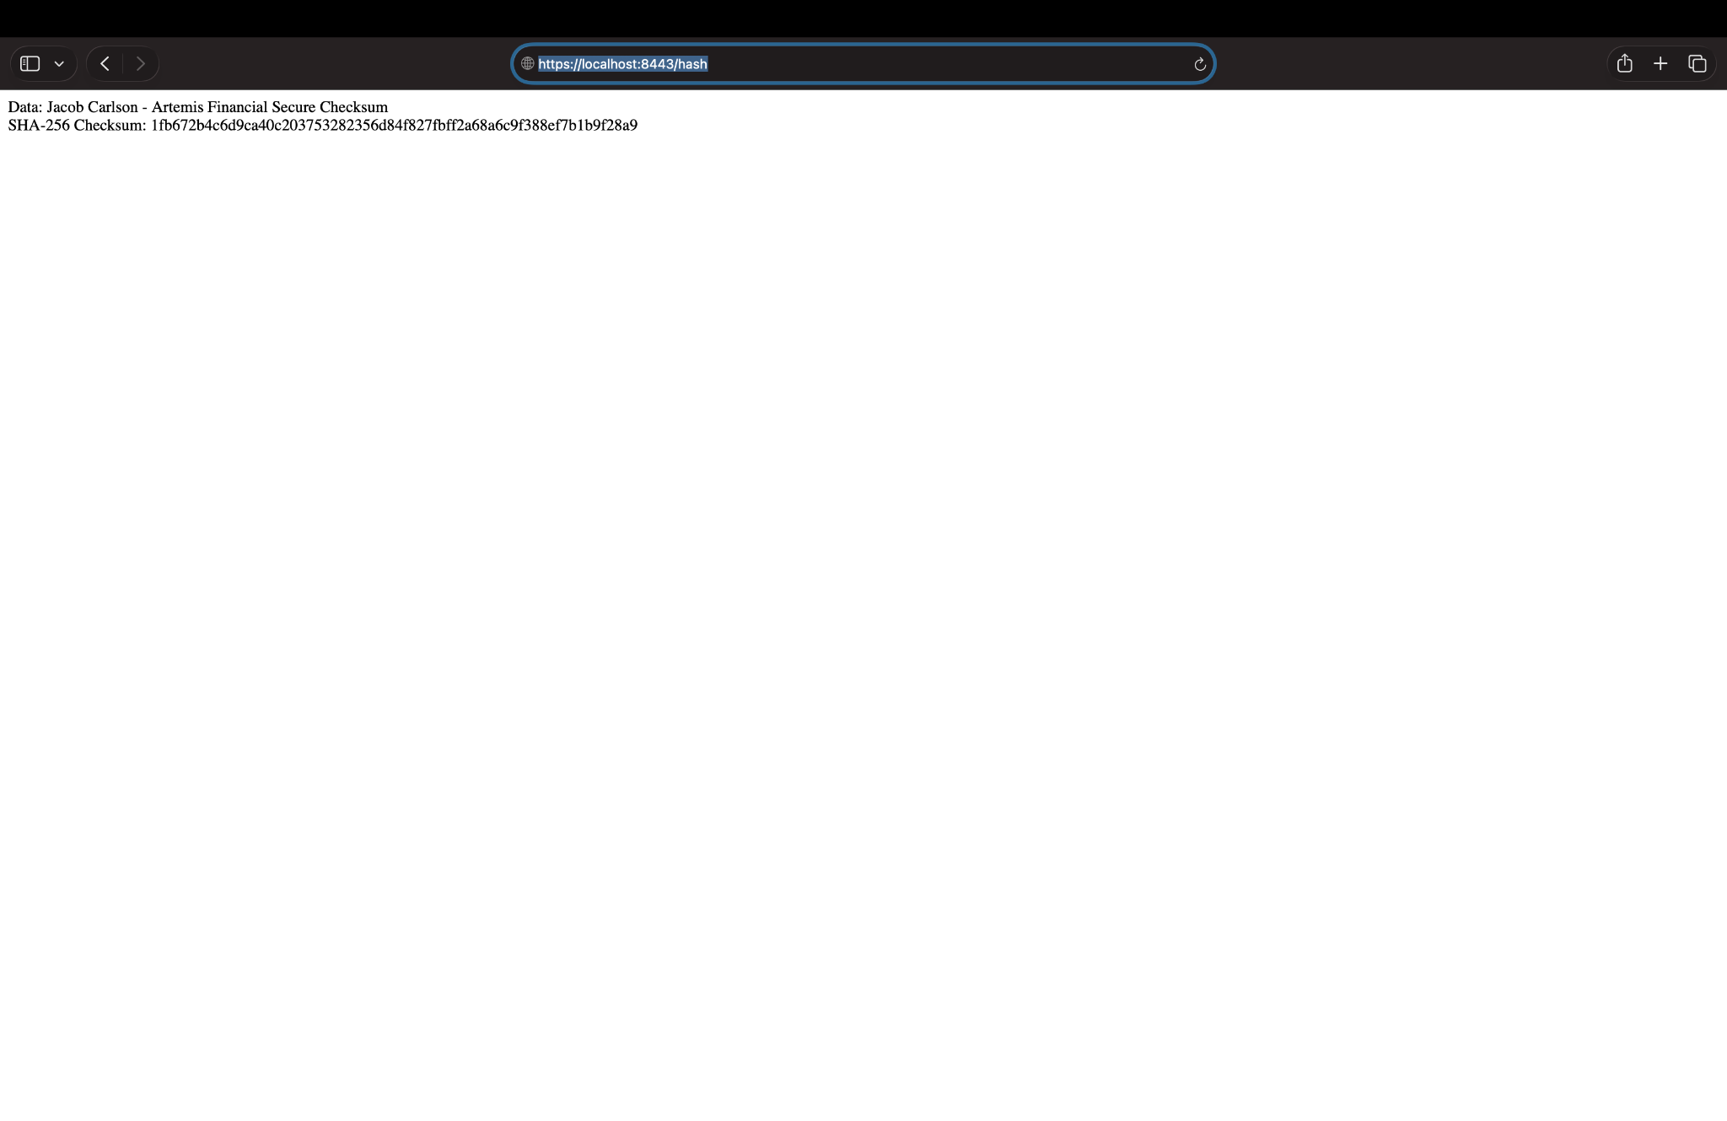

Summary
For this project, I refactored the Artemis Financial application to improve the security of the software and reduce possible vulnerabilities. One of the main changes was adding a SHA-256 hash function to the application. This allowed the program to create a checksum that can be used to verify whether data has been changed. I also generated a self-signed certificate and configured the application to use HTTPS on port 8443 instead of normal HTTP communication.
These changes added multiple layers of security to the application. The SHA-256 checksum helps protect data integrity, while HTTPS protects information while it is being transmitted between the user and the application. The self-signed certificate and RSA key pair were used to support the secure HTTPS connection. I also used the OWASP Dependency-Check tool to review the project dependencies and identify known security vulnerabilities.
The vulnerability assessment process helped identify areas where the application could be improved. After the code was refactored, I tested the application to make sure it still compiled and ran correctly. I also verified that the /hash endpoint worked through HTTPS and that the checksum was generated successfully. The Dependency-Check scan also showed that several older dependencies contain known vulnerabilities. These results show that security should be reviewed throughout the development process and that dependencies should continue to be updated as new vulnerabilities are discovered.

Industry Standard Best Practice
Industry-standard secure coding practices were used throughout the refactoring of the Artemis Financial application. The application uses the SHA-256 hashing algorithm to create a checksum and help verify data integrity. HTTPS was also implemented to protect data transmitted between the client and server. A certificate and RSA key pair were configured to support the encrypted HTTPS connection.
The OWASP Dependency-Check tool was used to identify known vulnerabilities within the application's third-party dependencies. The dependency-check report showed that several dependencies contained known vulnerabilities, demonstrating the importance of regularly scanning and updating software dependencies. Keeping frameworks, libraries, and other components up to date can reduce the risk associated with publicly known vulnerabilities.
Additional security best practices include using strong encryption and hashing algorithms, protecting cryptographic keys and certificates, validating user input, following the principle of least privilege, and performing vulnerability testing throughout the software development life cycle. For a production environment, certificates should be issued by a trusted certificate authority rather than relying on a self-signed certificate. Continuing to perform dependency checks and security testing will help Artemis Financial maintain the confidentiality, integrity, and availability of its systems and customer information.

